Problem 1

Question: Write a program that prompts the user to enter two integers and checks whether the first number is divisible by the second.

Program code

#include<iostream>

using namespace std;

int main()

{

int a,b;

cout<<" Enter two integers: ";

cin>>a>>b;

if(a%b ==0)

cout<<a<<" is divisible by "<<b<<endl;

else cout<<a<<" is not divisible by "<<b<<endl;

return 0;

}

Program analysis

Read two numbers .Use a if statement to check whether the two number is divisible.

Program result

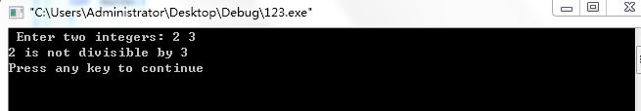

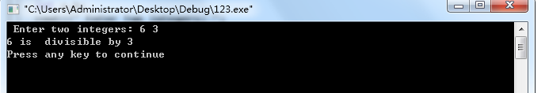

Problem 2

Question:

A shipping company uses the following function to calculate the cost (in dollars) of shipping based on the weight of the package (in pounds).

c(w)=3.5     if 0<w<=1

5.5            if 1<w<=3

8.5            if 3<w<=10

10.5  if 10<w<=20

Program code

#include<iostream>

using namespace std;

int main()

{

double w;

cin>>w;

if (w<=1) cout<<3.5<<endl;

else if (w<=3) cout<<5.5<<endl;

else if (w<=10) cout<<8.5<<endl;

else if (w<=20) cout<<10.5<<endl;

return 0;

}

Program analysis

Use several if statements to calculate the cost

Program result

Problem 3

Question:

Write a program that prompts the user to enter a point (x,y) and checks the point is within the circle centered at (0,0) with radius 10. For example, (4,5) is inside the circle and (9,9) is outside the circle. (**Note, the point coordinate x and y should be declared as float data type and the comparison between two float point numbers should be used correctly.**)

Program code

#include<iostream>

#include <math.h>

using namespace std;

int main()

{

float x,y,d;

cout<< " enter a point (x,y) " ;

cin>>x>>y;

d=sqrt(x*x+y*y);

if (d<10) cout<<"the point is inside the circle "<<endl;

else if (d==10) cout<<"the point is on the circle "<<endl ;

else cout<<"the point is outside the circle "<<endl ;

return 0;

}

Program analysis

Use the Pythagoras theorem to calculate the distance from the point to the center .then use a if statement to check the position of the point .

Program result

